JUNIOR BIOLOGY OLYMPIAD QUESTIONS
- An experiment was set up to investigate tropism as shown below:
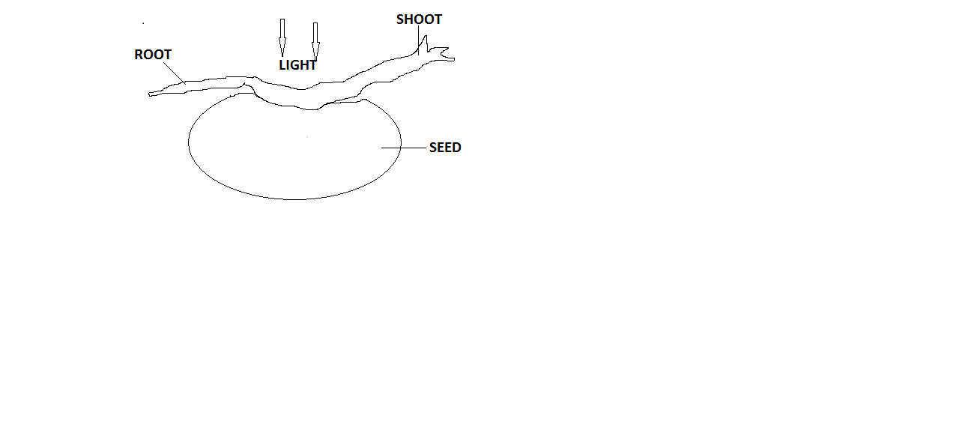
- Draw what is expected of the experiment after 7 days. [4]
- State the type of tropism exhibited by (i) the root and (ii) the shoot in your diagram. [2]
- Explain the purpose of positive hydrotropism. [2]
- What is tropism? [2]
ANSWERS
- (a)
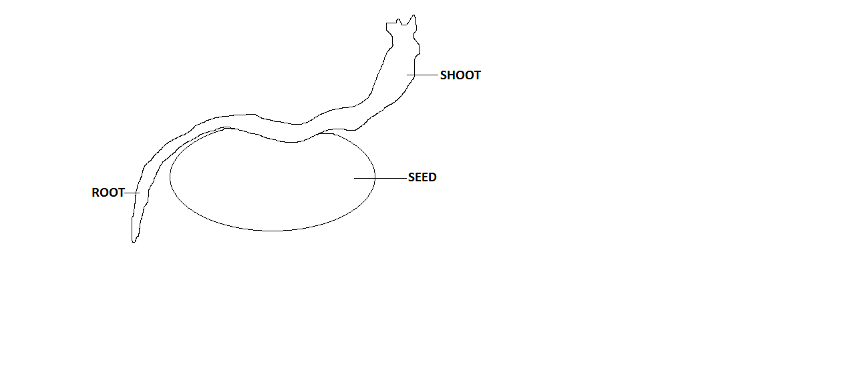
(b) (i) positive geotropism (ii) positive phototropism
(C) Enables roots to absorb water.
(d) The growth response of a plant to stimuli.
2. Write short notes on the following types of heterotrophism nutrition.
(a) phagocytosis. [2]
(b) parasitism. [2]
(c) saprophytism. [2]
(d) holozoic nutrition. [2]
ANSWERS
- Phagocytosis – mode of feeding in which single celled organisms like amoeba and certain white blood cells feed on solid food materials.
– they engulf food particles through the formation of pseudopodia which captures the food material and encloses it in a food vacuole.
– This is digested by enzymes and soluble products are absorbed into cytoplasm.
– The undigested are voided out.
- Parasitism – mode of feeding where one organism, the parasite obtains food from another organism, the host.
- The host does not benefit from the association but loses.
- The parasite can live on the outside of the host e.g. tick or within the host e.g. tapeworms.
- Saprophytism – mode of feeding where the organism feeds on decaying organic matter.
- Enzymes are secreted on the decaying matter and after digestion the soluble products are absorbed into the body of the organism.
- This type of feeding is exhibited by some bacteria and fungi.
- This digestion in this mode of feeding is called extracellular digestion.
- Holozoic nutrition – organisms ingest, digest, absorb, assimilate and egest organic matter.
- This is exhibited in three ways namely in different animals as herbivorous, carnivorous and omnivorous mode of feeding.

3. (a) name the parts of a lipid molecule. [2]
(b) Differentiate between:
(i) Fats and oils. [3]
(ii) Light independent and light dependent reaction in photosynthesis. [2]
(c) State three functions of lipids in animals. [3]
ANSWERS
3. (a) – fatty acid molecules.
- Glycerol molecules.
(b) (i) – fats are soliod at room temperature while oils are liquid at room temperature.
- Fats are found in animals while oils are found in plants.
(ii) – light independent stage takes place in the absence of light.
- Hydrogen is incorporated into carbon dioxide to form glucose using ATP.
- Hydrogen is used to reduce carbon dioxide into carbohydrate.
- This process is called carbon (iv) oxide fixation.
- It takes place in the stroma of the chloroplast.
- Light dependent reaction requires light energy from the sun trapped by chlorophyll into chemical energy.
- Energy is used to split a water molecule into hydrogen and oxygen.
- Hydrogen ion and ATP are formed.
(c) – they form the components of cell membrane
- They are source of metabolic water
- They are a source of energy when oxidised
- They insulate the animal bodies against heat loss
4. (a) what is an enzyme? [1]
(b) (i) state and explain briefly the three characteristics of enzymes. [3]
(ii) How are enzymes affected by temperature and pH? [2]
(c) State the functions of the following enzymes
(i) Rennin
(ii) chymotrypsin
ANSWERS
4. (a) it is a biological catalyst which speeds up biochemical reactions without changing in their structure at the end of the process.
(b) (i) –they are specific in the types of reactions they catalyse.
- They act best within specific pH range
- They are affected by temperature change
- They are not used up in the reactions
(ii) – at low temperatures, enzymes are inactive, at high temperatures, enzymes are denatured.
- Therefore, enzymes have an optimum temperature.
- Some enzymes work well in acidic medium while others work well in alkaline medium.
- The enzymes that work well in acidic medium stop working when they are in alkaline medium.
(c) (i) rennin
- These are enzymes found in the stomach of young mammals whose diet is mainly milk.
- They break down proteins found in milk.
- It converts soluble milk casinogen into casein that can then be converted into peptides by the enzyme pepsin.
(ii) chymotrypsin
- This is secreted in an inactive form chymotrypsinogen.
- It converts the remaining proteins into smaller peptides.

- Using you knowledge in science answer the following questions
  - Blood is part of the circulatory Complete the following statements using the correct word(s) from the following lists
Plasma
Red blood cells
white blood cells
Platelets

- The Liquid part of blood is known as
_______________________ [1]
- Oxygen gas is carried around the body by the
_______________________ [1]
- Complete the question of respiration below

Glucose + _________ ----------------> Energy + Carbon dioxide _________[2]
- Explain how each of the following changes in the environment might affect the rate
of photosynthesis.
- An increase in temperature from 10 °C to 20 °C
_______________________________________________________________________________________________________________________________________________________________________________________________________________________________________________________________________________________________________________[3]
- An increase in light intensity
________________________________________________________________________________________________________________________[2]
- What is the name the substance that traps light for photosynthesis
___________________________________________________________[1]

ANSWERS

Question Number | Answer | Mark
5 a (¡) | Plasma | 1
5 a (¡¡) | Red blood cells | 1
5b | - Reactants ……..Oxygen  - Products ………. Water | 1  1
5 (c)(¡) | - Increase rate of photosynthesis  - Increase enzyme active  - energy for molecule to have more collisions for reaction | 1  1  1
5 (c) (ii) | - Increase rate of photosynthesis  - more light is tapped/absorbed | 1  1
5 (c)(ii) | - Chlorophyll | 1

- The following diagram shows the flow of blood through the lungs, heart and the
rest of the body.
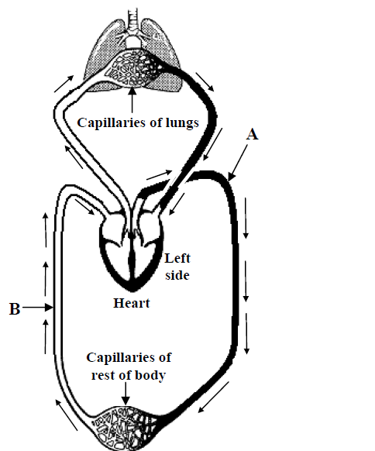

- Name the blood vessels labelled A and B
A ________________________________________
D________________________________________
- Describe two changes in the Composition of blood after it has passed through the capillaries of the lungs
- Name the chamber of the heart that pumps blood to the lungs
______________________________________________________
- Name a vein that Carries oxygenated blood
________________________________________________________

ANSWERS

Scheme
Question Number | Answer | Marks
6(i) | - Aorta  - Vena Cara | 1  1
6 (ii) | - Carbon dioxide removed resulting less CO2  - Oxygen added resulting move O2  - Water vapor removed | 2  2  2
6 (iii) | Right ventricle | 1
6 (iv) | Pulmonary Vein | 1

- The diagram below shows the human lungs and related structures.

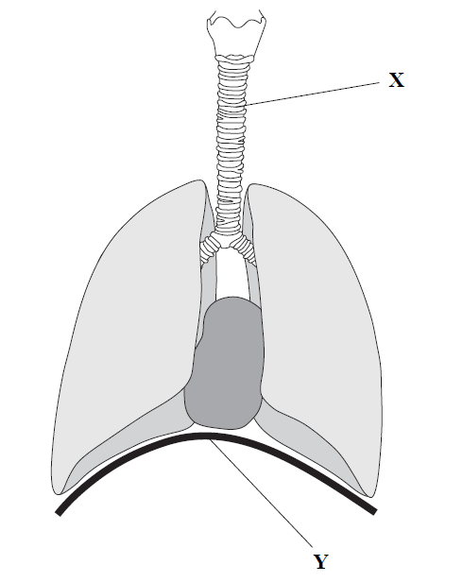
- Name the parts labelled X and Y
X ___________________________________________________
Y ___________________________________________________
- The table below shows the concentration of oxygen and of carbon dioxide in blood entering and leaving the Lungs.
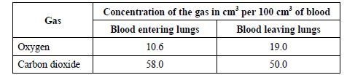
- How many cm3 of oxygen per 100 cm3 of blood are collected in the lungs?
____________________________________________________________
- Name the cells in blood that collect oxygen in the lungs.
____________________________________________________________
- Name the blood vessel that takes blood to the lungs from the heart.
____________________________________________________________
- Describe and explain how a carbon dioxide molecule passes from the blood into the lungs and how it is then breathed out.
ANSWERS

Scheme
Question Number | Answer | Marks
7 (a) | X = trachea  Y = diagram | 1  1
7 (b) (i) | 8.4 | 1
7 (b) (ii) | red blood Cells or erythrocytes | 1
7 (b) (ii) | Pulmonary artery | 1
7 (c) | 1 Mark for each point  Maximum 5 Marks  - Process of diffusion  - Oxygen dissolve in film of moisture  - the concentration gradient causes diffusion  - the diaphragm relays  - Rib Cage lowers  - Air passes in the trachea to the bronchi to the bronchioles to air sacs | 5
\

- (a) Explain the effect of the following hormones on leaves and fruits. [4]
  - Cytokinins
  - Abscisic acid
  - What is the effect of gibberellins on meristems, stem, fruit and seed? [4]
(b) Give one economic importance of ethylene (ethane). [2]
ANSWERS
- (i)
- it delays ageing of leaves
- promotes fruit development.
(ii) – promotes leaf abscission
- Promotes fruit abscission
(iii) – increases cell division in meristems
- Increases cell elongation in stem
- Promotes fruit development
- Initiates seed germination.
- – It is used in ripening and harvesting fruit.
- (a) Define a disease. [2]
(b) What is meant by the following terms in diseases: [8]
(i) Signs
(ii) Symptoms
(iii) Incubation period
  - Pandemic

ANSWERS
9. (a) A condition which changes the normal functioning of a living organism.
(b)
- Signs – visible expression of the disease which can be found by examining a patient e.g. rash or high temperature.
- Symptoms – an indication of a disease which is not detectable by examination and can only be reported by the patient e.g. headache, nausea.
- Incubation period – the period of time between the original infection and the appearance of signs and symptoms.
- Pandemic – an epidemic which spreads across whole continents.
- (a)cholera is a common bacterial disease.
  - Name the bacterium that causes it. [1]
  - How is the disease transmitted? [2]
  - How is the disease prevented? [2]
(b) the Aquired Immune Deficiency Syndrome (AIDS) is a viral disease.
(i) Name the virus that causes the disease. [1]
(ii) How is the disease transmitted? [2]
(iii) How can the disease be prevented? [2]
ANSWERS
10. (a) (i) vibro cholera
(ii) – the bacterium is passed in stools or vomit of patients with a disease.
- Transmission is normally through infected drinking water and contaminated food.
(iii) – strict personal hygiene.
- Drinking water should come from an uncontaminated piped supply or be boiled.
- Flies must not be allowed to contaminate food.
(b) (i) Human Immunodeficiency Virus (HIV)
(ii) – mainly through close sexual intercourse.
- Unscreened blood for transfusion and injection by unsterilized needles and cuts by contaminated razor blades also transmits the disease.
(iii) – avoid unsafe sex and the use of condoms during sexual intercourse reduce the risk of catching AIDS.

- (a) state three functions of a skeleton. [3]
(b) describe the following bone tissues:
(i) solid bone
(ii) spongy bone
(iii) ligaments
- What is a hinge joint? [1]

ANSWERS
11. (a) – supports the body
- Protects the body organs
- Helps with movement.
(b) (i) solid bone – the compact or very hard part of the bone usually found along the outer edges of bones.
(ii) spongy bone – part of the bone with many empty spaces and usually found towards end of the bones.
(iii) Ligaments – tough fibres that hold one bone to another. They are usually found at bone joints where two bones come together.
(c) A joint that allows bones to move only back and forth.

- (a) distinguish between producer and primary consumer. [2]
(b) name four density-dependent factors in an ecosystem. [4]
(c) distinguish between commensalism and mutualism and give an example for each. [4]

ANSWERS
12. (a) producer – the organism at the first trophic level in an ecological pyramid which carries out photosynthesis.
- Primary consumers - are the organisms at the second trophic level in an ecosystem pyramid usually a herbivore.
(b) (i) competition (ii) emigration (iii) predation (iv) paratism
(c) Commensalism – is an association between organisms of two or more different species in which one of the commercial benefits and the other neither benefits nor is harmed.
Mutualism – is an association between two or more organisms of different species both derive mutual benefits.
- (a) using a well labelled diagram, illustrate the three pathways in which water passes; [5]
  - Apoplast pathway
  - Symplast pathway
  - Vacuolar pathways
(b) what is main purpose of the following to a plant:
(i) water[1]
(ii) magnesium ions[1]
(iii) Phosphate ions [1]
(c)define the process by which water moves from the soil into the roots. [2]

ANSWERS
13. (a)
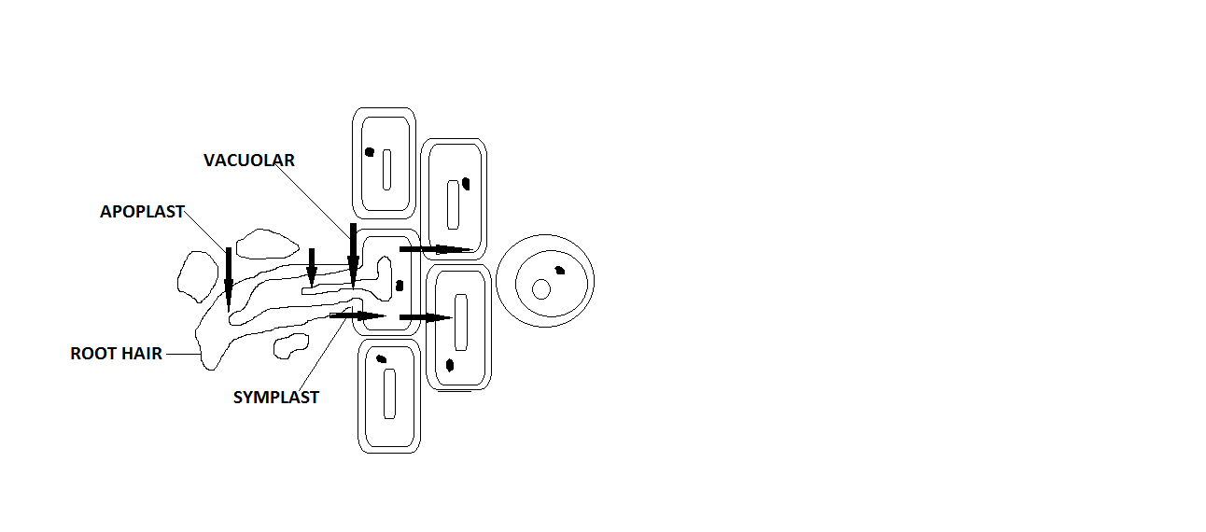
(b) (i) water- used in photosynthesis
(ii) magnesium ions – formation of chlorophyll
(iii) phosphate ions – development of roots
(c)osmosis – diffusion of water molecules across a selectively permeable membrane.

